Ideation Phase
Define the Problem Statements

Date | 16-10-2026
Team ID: | HP-MERN-2026
Project Name | HotelPro — Human-Centered Hotel Management System
Maximum Marks | 2 Marks

Customer Problem Statement Template:
To define the core problems hotel guests, front-desk staff, housekeeping teams, and administrators face during hotel discovery, booking checkout, and operational coordination, and use those insights to guide the architecture and design of HotelPro.
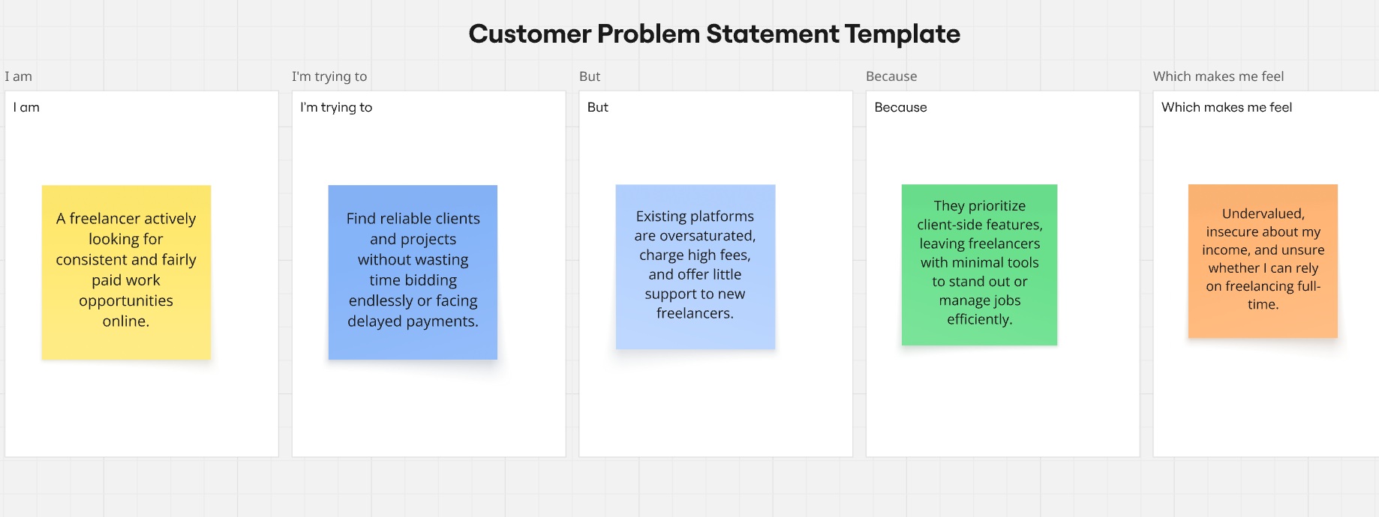
Reference: https://miro.com/templates/customer-problem-statement/

Problem Statement (PS) | I am (Customer) | I’m trying to | But | Because | Which makes me feel
PS-1 | Guest / Online Booker | search and compare boutique hotels across cities | mainstream platforms display cluttered sponsored ads, hidden fees, and confusing search filters | platforms prioritize monetization over clarity and user-centered design | overwhelmed, skeptical, and frustrated.
PS-2 | Guest / Traveler | complete room booking checkout smoothly and securely | payments frequently freeze or fail with network errors during peak times | third-party gateways lack graceful offline simulation and zero-error fallback | anxious about losing my reservation or being double-charged.
PS-3 | Guest / Corporate Traveler | access and print my stay invoice receipts easily | direct URLs to invoices are public or require digging through obscure menus | legacy platforms neglect invoice privacy and print-specific layout design | insecure regarding personal travel data exposure.
PS-4 | Front-Desk Receptionist | check in arriving guests and issue room keys quickly | the front-desk software is sluggish with multi-step menu navigation | traditional hotel management tools have bloated, poorly indexed databases and slow UI state sync | stressed and apologetic during peak guest check-in hours.
PS-5 | Housekeeping Manager | coordinate room cleaning schedules and inspection updates | room status updates rely on manual phone calls, walkie-talkies, or paper clipboards | there is no unified real-time dashboard linking housekeeping directly to front-desk inventory | disorganized and prone to assigning uncleaned rooms.
PS-6 | Hotel General Manager / Executive | monitor daily occupancy rates, RevPAR, and operational performance | reports are delayed or fragmented across separate static spreadsheets | antiquated systems lack interactive, real-time data visualizers and unified audit logs | uninformed when making urgent pricing, staffing, and room rate decisions.

